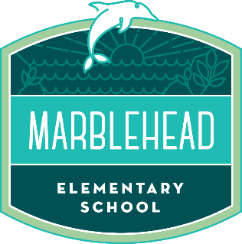

**New Student Registration Checklist**

**Bring:**

**____ Verification of Age** (official or certified copy of the birth record; statement by the local registrar or county recorder certifying the date of birth; baptismal certificate or official hospital record of birth; passport; or Affidavit for Proof of Age of Minor signed by the student’s parent/legal guardian)

**____ 2 Proofs of Residence** – (Current utility bill [gas, electric, water/sewage]), mortgage statement or rental agreement, an escrow statement followed by verification of closing documents, property tax bill, bank statements, moving company receipts, and/or service letter from a utility company verifying residency)

**____ Immunization Record**

**____ Online Registration Print out and Confirmation** - Please print and bring to the school office. The last page requires a parent signature. https://airregistration.capousd.org/AIR/

**Fill out and Bring:** (Forms included in this packet):

**____ Home Language Survey**

**____ Enrollment Questionnaire** – Programs your child may have participated in, medical needs, custody issues, IEP (Please provide office with copies if any of these apply to your child)

**____ Report of Health Examination (due by start of 1st grade)** – Completed and signed by physician.

**REGISTRATION PACKETS WILL ONLY BE ACCEPTED IF ALL OF THE REQUIREMENTS ARE MET AND THE PACKET IS COMPLETE!**